**Prerequisites: Software data transmission**

* Matlab Toolboxes:
  + Data Acquisition Toolbox
  + ROS Toolbox
* NI Software:
  + NI MAX App
* Matlab files
  + in the working directory of the publisher:
    - AutomaticStop_ROS1_pub
    - ROS_publish
  + in the working directory of the subscriber:
    - final_ROS1_sub
    - StartButton
    - StopButton
    - ros1_header2table
    - ros1_wrench2table

**Manual: Software data transmission**

1. Create the Master ROS node for the publisher with the script *AutomaticStop_ROS1_pub*. Type in *rosinit* in the command line*.* The ROS master name which is displayed in the command window is necessary for the next step.

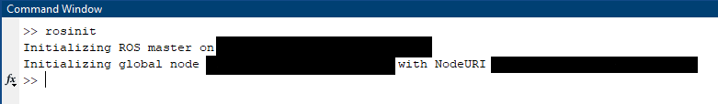

**Master name**

Figure 1: Creation Master Node

1. Enter subject number into field ENTER VALUES. If the measurement is continuous, set iscont =1, if not set iscont =0 and add the duration time in seconds.

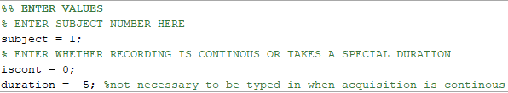

Figure 2: Enter relevant information for publisher

1. Create the ROS node for the subscriber with the script *final_ROS1_sub*. Type in *rosinit(‘*ROSMasterName*’)* and add the name of the ROS master that was created above as a string in between the brackets.

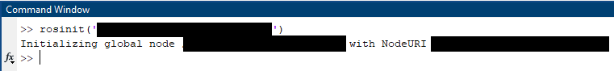

**Master name**

Figure 3: Enter relevant information for subscriber

1. Enter subject number into field ENTER VALUES. Additionally, enter the duration time in seconds you want to receive data from.

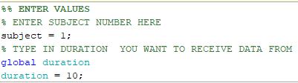

Figure 4: Enter relevant information for subscriber

1. Start running the script of the subscriber. A GUI will open. Press Start Streaming.

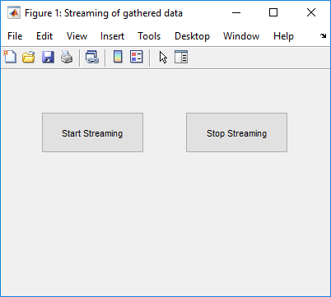

Figure 5: GUI for the subscriber

1. Then start running the script of the publisher. If the measurement is not continuous but lasts for a certain amount of time, no additional steps need to be taken. If the measurement is continuous, a figure window pops up.

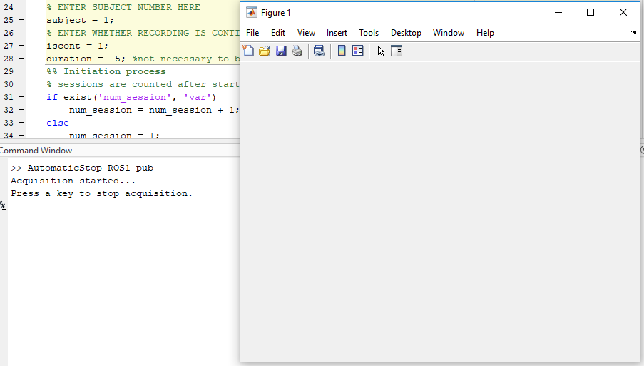

Figure 6: Figure pop up for continuous acquisition

To stop the acquisition of the data, one needs to click on the figure or press a key. The figure is then closed and the acquisition is stopped as well. After 30 seconds the acquisition is stopped automatically. The raw data is saved in a separate file.

|  |  |
| --- | --- |
|  |  |
| *Figure 7: Final text displayed in the publisher when measurement is not continuous* | *Figure 8: Final text displayed in the publisher when measurement is continuous* |

1. When successfully receiving the data, the subscriber gives information about how many seconds of data had been sent already. If the wished amount is received, the GUI can be used again to press Stop Streaming. The data is then saved in different files for each ROS topic.



Figure 9: GUI for the subscriber

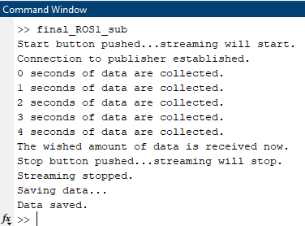

Figure 10: Final text displayed in the subscriber